**Guided Capstone Project Report**

Introduction

Big Mountain Resort (BMR) is a winter sports lodge located in Montana which typically hosts around 350,000 customers every year. The data science team was contracted to answer the question of if it is feasible to increase the ticket price considering data from other winter lodges and whether certain business features being considered for removal or being added would be worth the change in income. In addition to the adjusted ticket price, specific changes this project was given for consideration included: removing multiple runs, adding a new run which raises the total vertical drop by 150 ft and a new chair, the same aforementioned but also add two acres of snow making, and adding a fifth of a mile length to the longest run by adding four acres of snow coverage.

Ticket Price Core Adjustment

The old pricing model was based on comparing an overall general average with other winter sports lodges at approximately the level of luxury features existed. This new model is similar in scope but takes a deep dive into the specific details of all features to find out their true value. The original price model came up with a $81.00 ticket. The new model comes to a $95.81 ticket price based on current features with a $10.39 range of the absolute mean error. Therefore definitive room for a price increase. This new model does not explicitly take into account advertisements so this should be considered before any final decision is made on a final ticket price. Without going into detail, the easiest way to show why BMR is worth this ticket price is to show the key areas it is ahead of the curve. As seen in figure 1 with the red dashed line representing where BMR is on each scale, there are many important features, even more beyond those shown, which BMR excels at.

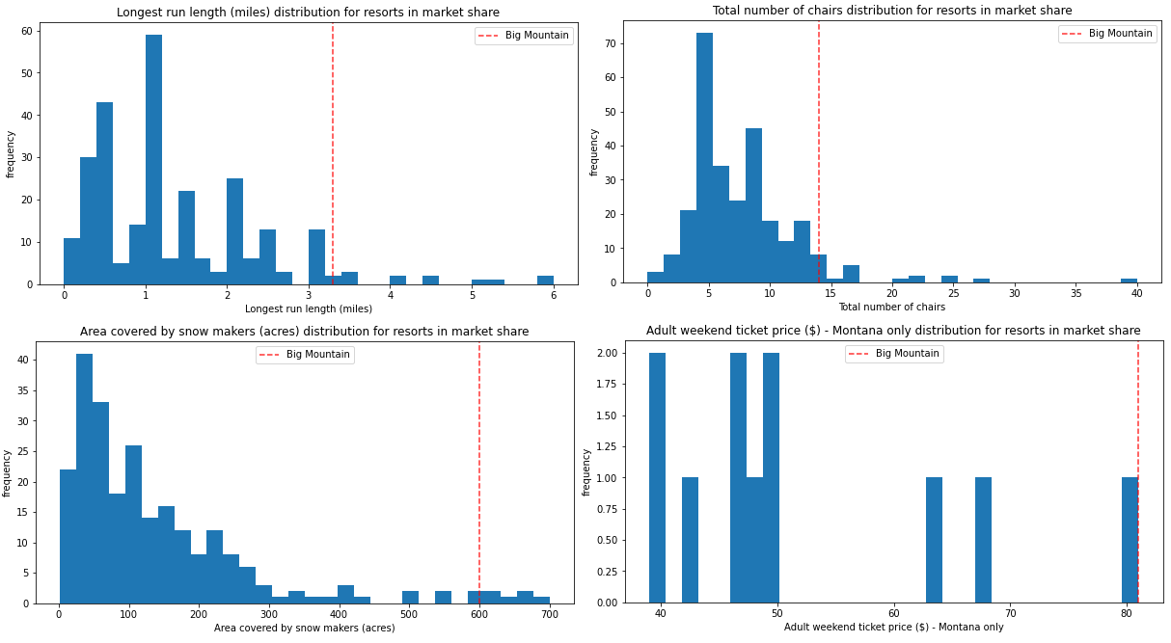

*Figure 1: Big Mountain Resort Feature Ranking*

Decreasing Run Count

The first alternative scenario suggested was to decrease the run count, removing the least popular runs, up to ten. The data shows several options to minimize ticket price decrease while reducing the most cost.

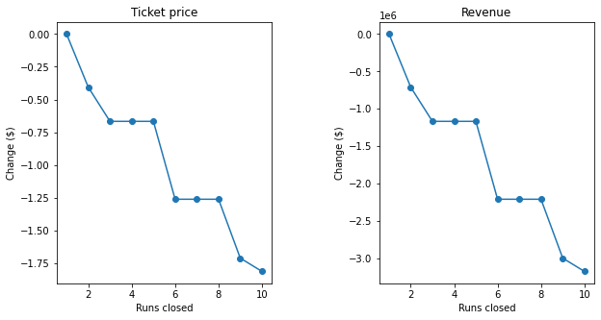

*Figure 2: Revenue and Ticket change from Run Closure*

As seen in figure 2, the data suggests the best options would be to close one, five, or eight runs. With closing just one run being the best option with no price change in ticket value.

Increased Vertical Drop with and without Snow

The next two options were to model increasing the vertical drop by 150 ft and installing a chair lift with two variations; one with artificial snow and one without. The model says this would increase the price by $8.61 and $9.90 respectively.

Increase Longest Run

The fourth feature change asked to be modeled was to extend the longest run by a fifth of a mile by adding more artificial snow. The model shows this would adjust the price by $0. This change is not recommended.